Saugus Girls Soccer
Player Handbook/Contract
2022-2023

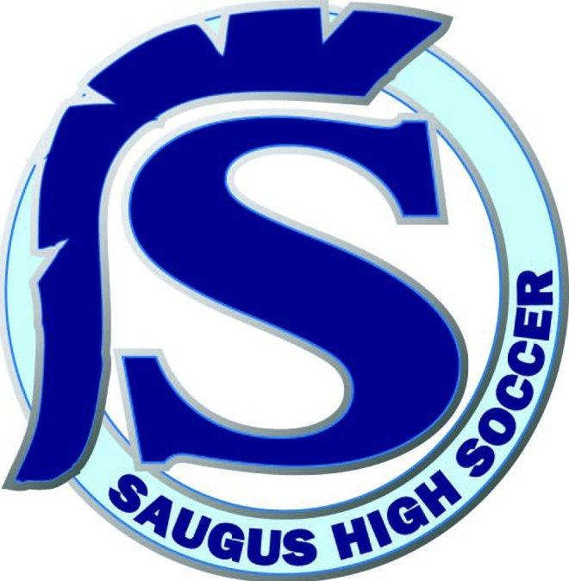
Congratulations on being chosen as a member of the Saugus Centurion squad for the 2021-2022 season. In order for us to have a successful season, it is important that coaches, players, and parents all understand and follow the expectations set by our program, the Foothill League, and CIF-SS. If there are any questions, please do not hesitate to email your team’s head coach.

PLAYERS:

TRAINING RULES and GUIDELINES
- Be on time to all training sessions and games
- Be prepared and organized with equipment
- Come to every practice properly dressed with the following:
  - Saugus Soccer t-shirt, soccer shorts, soccer socks, shin guards, and cleats
- Contact your coach via text/phone/email if you will be late to practice or cannot attend
- Be supportive of all girls in the program. No matter what team you are on, we are all apart of Saugus Girls Soccer
- The following actions WILL NOT BE PERMITTED\
  - Cussing, ditching, fighting, drinking/drugs/smoking, quitting/walking away from a game, arguing with the coach, throwing/damaging program equipment
- At every practice or game be respectful of your teammates, your coach, and anyone involved in the Saugus Athletics Program
- Remember that we are all representing Saugus High School and the Girls Soccer Program

BE A PERSON OF INTEGRITY
- Display exemplary citizenship and sportsmanship, on and off the field
- Show respect for yourself, your teammates, your opponents, your coaches, and the officials
- Understand your role on the team and always do your best to excel at your role
- Place the team and its objectives before your own
- Stay committed to the team from the first practice through the final game

BE A LEADER
- Be a positive example for other players in the program
- Give your best effort at all times
- Represent Saugus with pride
- Maintain a positive attitude in all circumstance and situations
- Be willing to sacrifice your own desires for the good of the team
- Follow all training rules and guidelines
- Take care of al school facilities
- Even if you are not a captain, you can still be a leader for the team. With a positive attitude and a hard work, our team can thrive if all players conduct themselves with this type of attitude

CONSEQUENCES
Every player will be held accountable for her actions. It is up to each coach to decide the consequences for players who break training rules and guidelines. Possible consequences are:
- Extra conditioning
- Not starting a game
- Decrease in playing time
- Expulsion from the team

ACADEMIC RESPONSIBILITIES
- Players are expected to maintain a 2.0 GPA in order to participate on any athletic team. Grades will be checked by school administrators at the first quarter progress reports and at the end of each semester
- Your behavior in the classroom is your first priority. Failure to do well in the classroom could result in your expulsion from the program
- You must attend and be on time to ALL classes. On game days, if you miss any class, you will not be allowed to participate in the game. This is a district rule and there are no exceptions! If a player is suspended from school, the player is ineligible to compete in games, participate in practice or conditioning during the time of the suspension. This includes in-school suspensions.
- Coaches are extremely willing to help a player with her studies, but no coach will be involved in trying to get a grade changed for any player. You earn your own grades and must take responsibility for your academics

PRACTICE TIMES
We will practice 5 days a week from 2:30-4:30 (or later). These times may change occasionally based on each coach’s discretion. The varsity team will practice on the turf field. Frosh and Junior Varsity will practice at Central Park. You have made the commitment to be on this team, and that includes practice and games during Winter Break (All Levels). I expect players to be physically fit and ready to go for the league season.

8th PERIOD SOCCER
All players must be enrolled in 8th period soccer during preseason, season, and postseason UNLESS they are participating in another sport or are currently a senior and they have fulfilled all of their PE credits. 9th-11th grade student athletes must stay enrolled in 7th period after soccer season if they desire to play the following year.

TEAM SELECTION and PLAYING TIME
- Years in school, program experience, or club experience are NOT considerations for making a team or gaining playing time
- Skill, alone, is NOT the standard for making a team. We want players who have a great attitude, are dedicated to the program, have an excellent work ethic, a desire to improve individually and as a team, and have passion for the game
- There is no guaranteed amount of playing time and there are many factors that can affect the amount of playing time for a particular player, the policy of the program is that playing time is earned and not given. Starting positions and playing time are both earned. Coming to practice regularly and by working hard, competing and concentrating during practices and games will help increase playing time
COMMITMENT
Once an athlete has accepted a position in the program, the athlete is expected to attend every meeting, practice, and game. Coaches should be consulted at least 48 hours in advance of any conflict. Before trying out for a team, the ability to sustain the time commitment through an entire season should be considered by the player and their family. This includes games and practices during Winter Break (All Levels).
ELIGIBILITY
Saugus complies with the eligibility requirements mandated by the CIF-SS. The following condensed eligibility guidelines should be used for initial eligibility assessment. (For clarification of any rule, including eligibility, please contact our Athletic Director, Jeff Hallman)
- The athlete must be under the age of nineteen by September 1.
- The athlete must meet school attendance requirements
- The athlete must be scholastically eligible (minimum 2.0 GPA). The eligibility status will be evaluated at the end of each semester and end of summer session.
- The athlete must have met the residence and citizenship requirements.
- The athlete may not participate in any tryout for professional or collegiate teams without Athletic Department approval.
- The athlete may not compete on any outside team during the season that sport is played during the school year. YOU MAY NOT PLAY OR TRAIN WITH ANOTHER TEAM OR COACH AFTER THANKSGIVING WEEKEND.
- The athlete must be an amateur.
A player is not eligible for High School Athletics if:
- You have attended a 4 year high school for more than 8 semesters.
- You do not live with a legal guardian within the school boundaries or have the proper forms filled out that allows you to exercise your open enrollment rights.
- You are playing with another team during the high school season.
It is the responsibility of all transfer students to file the CIF-SS Transfer Eligibility Form and Pre-Enrollment Contact Affidavit with the CIF-SS office before competing. These forms are available in the Athletic Department or at www.cifss.org. All specific questions regarding eligibility should be directed to our Athletic Directors, George Lopata or Brandon Marcia or Assistant Principal Kullen Welch.

